**COMPOUND FUNCTIONS**

**Pearson Edexcel - Tuesday 19 May 2020 - Paper 1 (Non‑Calculator) Higher Tier**

**1.**

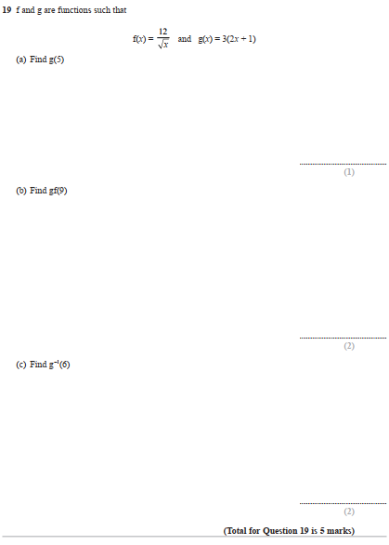

**Pearson Edexcel - Tuesday 21 May 2019 - Paper 1 (Non-Calculator) Higher Tier**

**2.**

**Pearson Edexcel - Tuesday 6 November 2018 - Paper 1 (Non-Calculator) Higher Tier**

**3.**

**Pearson Edexcel - Monday 12 November 2018 - Paper 3 (Calculator) Higher Tier**

**4.**

**Pearson Edexcel - Thursday 7 June 2018 - Paper 2 (Calculator) Higher Tier**

**5.**

**Pearson Edexcel - Monday 6 November 2017 - Paper 2 (Calculator) Higher Tier**

**6.**

**Pearson Edexcel - Specimen Papers Set 2 - Paper 2 (Calculator) Higher Tier**

**7.**

**Pearson Edexcel - Specimen Papers Set 1 - Paper 2 (Calculator) Higher Tier**

**8.**

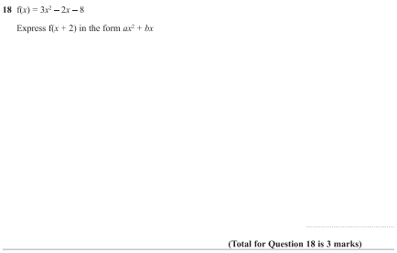

**Pearson Edexcel - Sample Paper 3 - (Calculator) Higher Tier**

**9.**

**10.**

